

**A Project**

**on**

**Cultivation of Aloe Vera: An analysis of its characteristic growth in different types of soil**

**Submitted to**

**Central Board of Secondary Education (CBSE)**

**in partial fulfillment of the requirements for the Term I Practical Examination-2021 of Class XII**

**Supervised by:**

**Mr. Lhakpa Wangyal**

**PGT Biology**

**Submitted by:**

**Vinayak Bhandari**

**XII PCB**

**Social Baluni Public School,**

**Haridwar By-Pass Road, Dehradun**

**DECLARATION**

This is to declare that the project entitled ‘**Cultivation of Aloe Vera: An analysis of its characteristic growth in different types of soil’** submitted in partial fulfillment of the requirement for the **Term I Practical Examination-2021** of **Class XII** is entirely an original work and all ideas and references have been duly acknowledged. It does not contain any work that has been submitted for the AISSE-2021 or any other board or institute.

**Supervised by:**

Mr. Lhakpa Wangyal

PGT Biology,

Social Baluni Public School,

Haridwar By-Pass Road, Dehradun

Submitted by:

Vinayak Bhandari

**CERTIFICATE**

This is to certify that project entitled ‘**Cultivation of Aloe Vera: An analysis of its characteristic growth in different types of soil**’ in partial fulfillment of the requirement for the **AISSCE-2022** of **Class XII** is a genuine work done under my supervision. No part of this project has ever been submitted for any other Exam, Degree or Diploma in this school or any other university or institute.

Mr. Lhakpa Wangyal

PGT Biology

Social Baluni Public School,

Haridwar By-Pass Road, Dehradun

**Acknowledgements**

The successful completion of this project work wasn’t mere sincerity, hard work and continuous strive for innovation and discoveries. I owe this project to many helpful, supportive and kind people who had been so kind in supporting and guiding in every milestones of this research. It gives me immense pleasure to express my sincere gratitude and hearty acknowledgements to all those who unconditionally helped me throughout my journey of research.

I am very thankful to the Central Board of Secondary Education (CBSE) for providing basic research facilities and infrastructure. It is my utmost joy that from the beginning to end and in every course of the research, my supervisor Mr. Lhakpa Wangyal (PGT Biology, Department of Biology, Social Baluni Public School, Haridwar By-Pass Road, Dehradun) had been so supportive and helpful. I am very honoured and privileged to have sir beside me all time for continuous guidance, inspiration and encouragement. I would take this opportunity to thank sir for his unwavering support and everything.

I am very thankful to Mr. Rawat, laboratory technician cum Head of laboratory, Department of Biology) and all the faculties and staffs for sincere and helpful assistance which will be remembered throughout my life.

I am also very grateful to every helpful and supportive people including my beloved family members, friends and all.

Vinayak Bhandari

Date: 19/10/21

**Table Of Contents……………………………………………………**Page no.

Declaration……………………………………………………………………i

Certificate…………………………………………………………………….ii

Abstract……………………………………………………………………...iii

Acknowledgement………………………………………………………...…iv

Table of Contents………………………………………………………...…..v

List of Tables………………………………………………………………...vi

Introduction

Objective of the investigatory project work

Materials Required

How I went about it?

Salient Features

**Introduction of my investigatory project**

Use of Aloe vera juice for skin care and health dates back to 6,000 years ago. Aloe vera gel with its antifungal and antibacterial qualities was used to improve immunity and longevity. Additionally, absorption of pollutants like formaldehyde, benzene, carbon monoxide and carbon dioxide from air by Aloe vera plant had been smart choice as a natural air purifier.

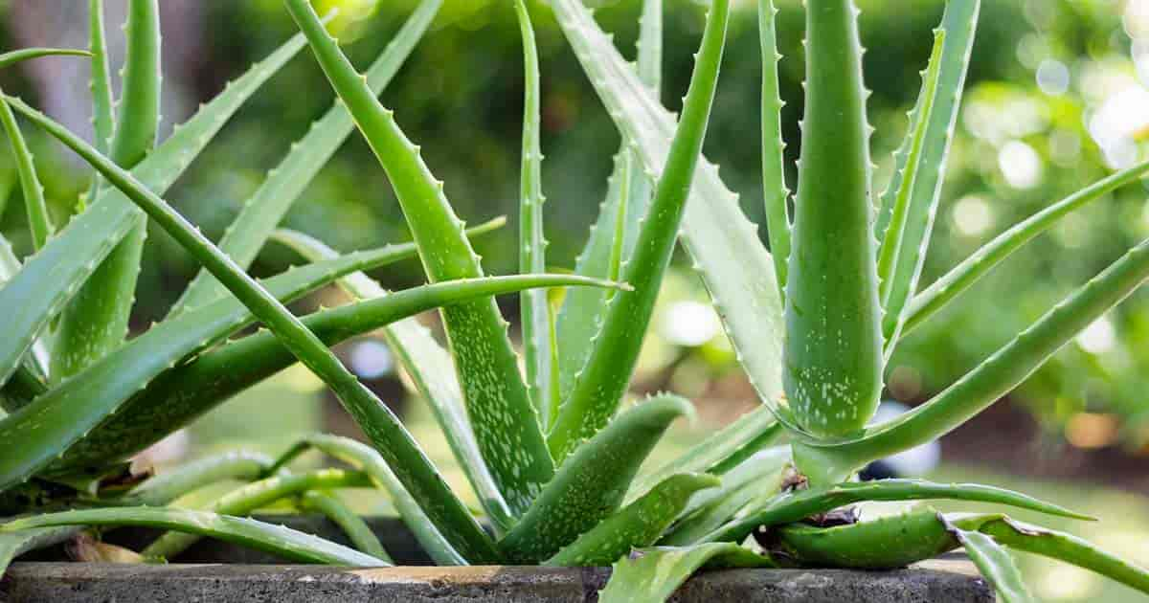

**Objective of this investigatory project work**

The objective of the investigatory project work was to examine characteristic growth of Aloe vera plant in different types of soil viz. sandy soil, loamy soil, and clayey soil. We used cut banana peel, cow dung, vermicompost and pit compost as organic manure.

**Materials Required:**

Jam plastic bottles, wooden plank, nail, hammer, saw, cutter, 2 mm transparent rubber pipe, pebbles, sandy soil, loamy soil, clayey soil, banana peel, cow dung, pit composed, vermicompost, etc.

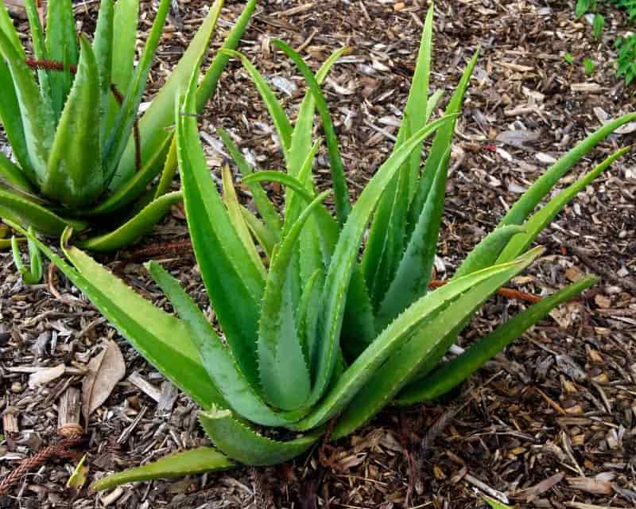

**How I went about it?**

Initially, I had pierced holes at the bottom of seven small sized plastic containers. To these containers, pebbles were arranged at bottom to ensure removal of excess water and three different soil types were added separately for growing Aloe vera.

I had also added cut pieces of banana peel, cow dung, vermicompost and pit compost as organic manure for healthy growth of Aloe vera in three of the pots of Aloe vera grown in different types of soil.

Later, similar sized Aloe Vera plants were planted gently in those plastic pots and sprinkled generous amount of water.

The apparatus was exposed to sunlight in school laboratory.

After two months, we had observed maximum growth of Aloe vera inside pot with sandy soil compared to its growth in loamy soil and clayey soil.

The pot with clayey soil had shown least growth.

The pots added with organic manure had exhibited better growth compared to the pots without manure.

**Salient Features:**

The objective of the investigatory project work was achieved by proper analysis characteristic growth of Aloe vera plant in different types of soil. Moreover, we came to know that addition of organic manure added quality growth of Aloe vera.

On the basis of our study, we would conclude that successful cultivation of Aloe vera requires sandy soil and organic manure.

According to our literature research, we became aware that cultivation of Aloe vera is economical and eco-friendly practice.